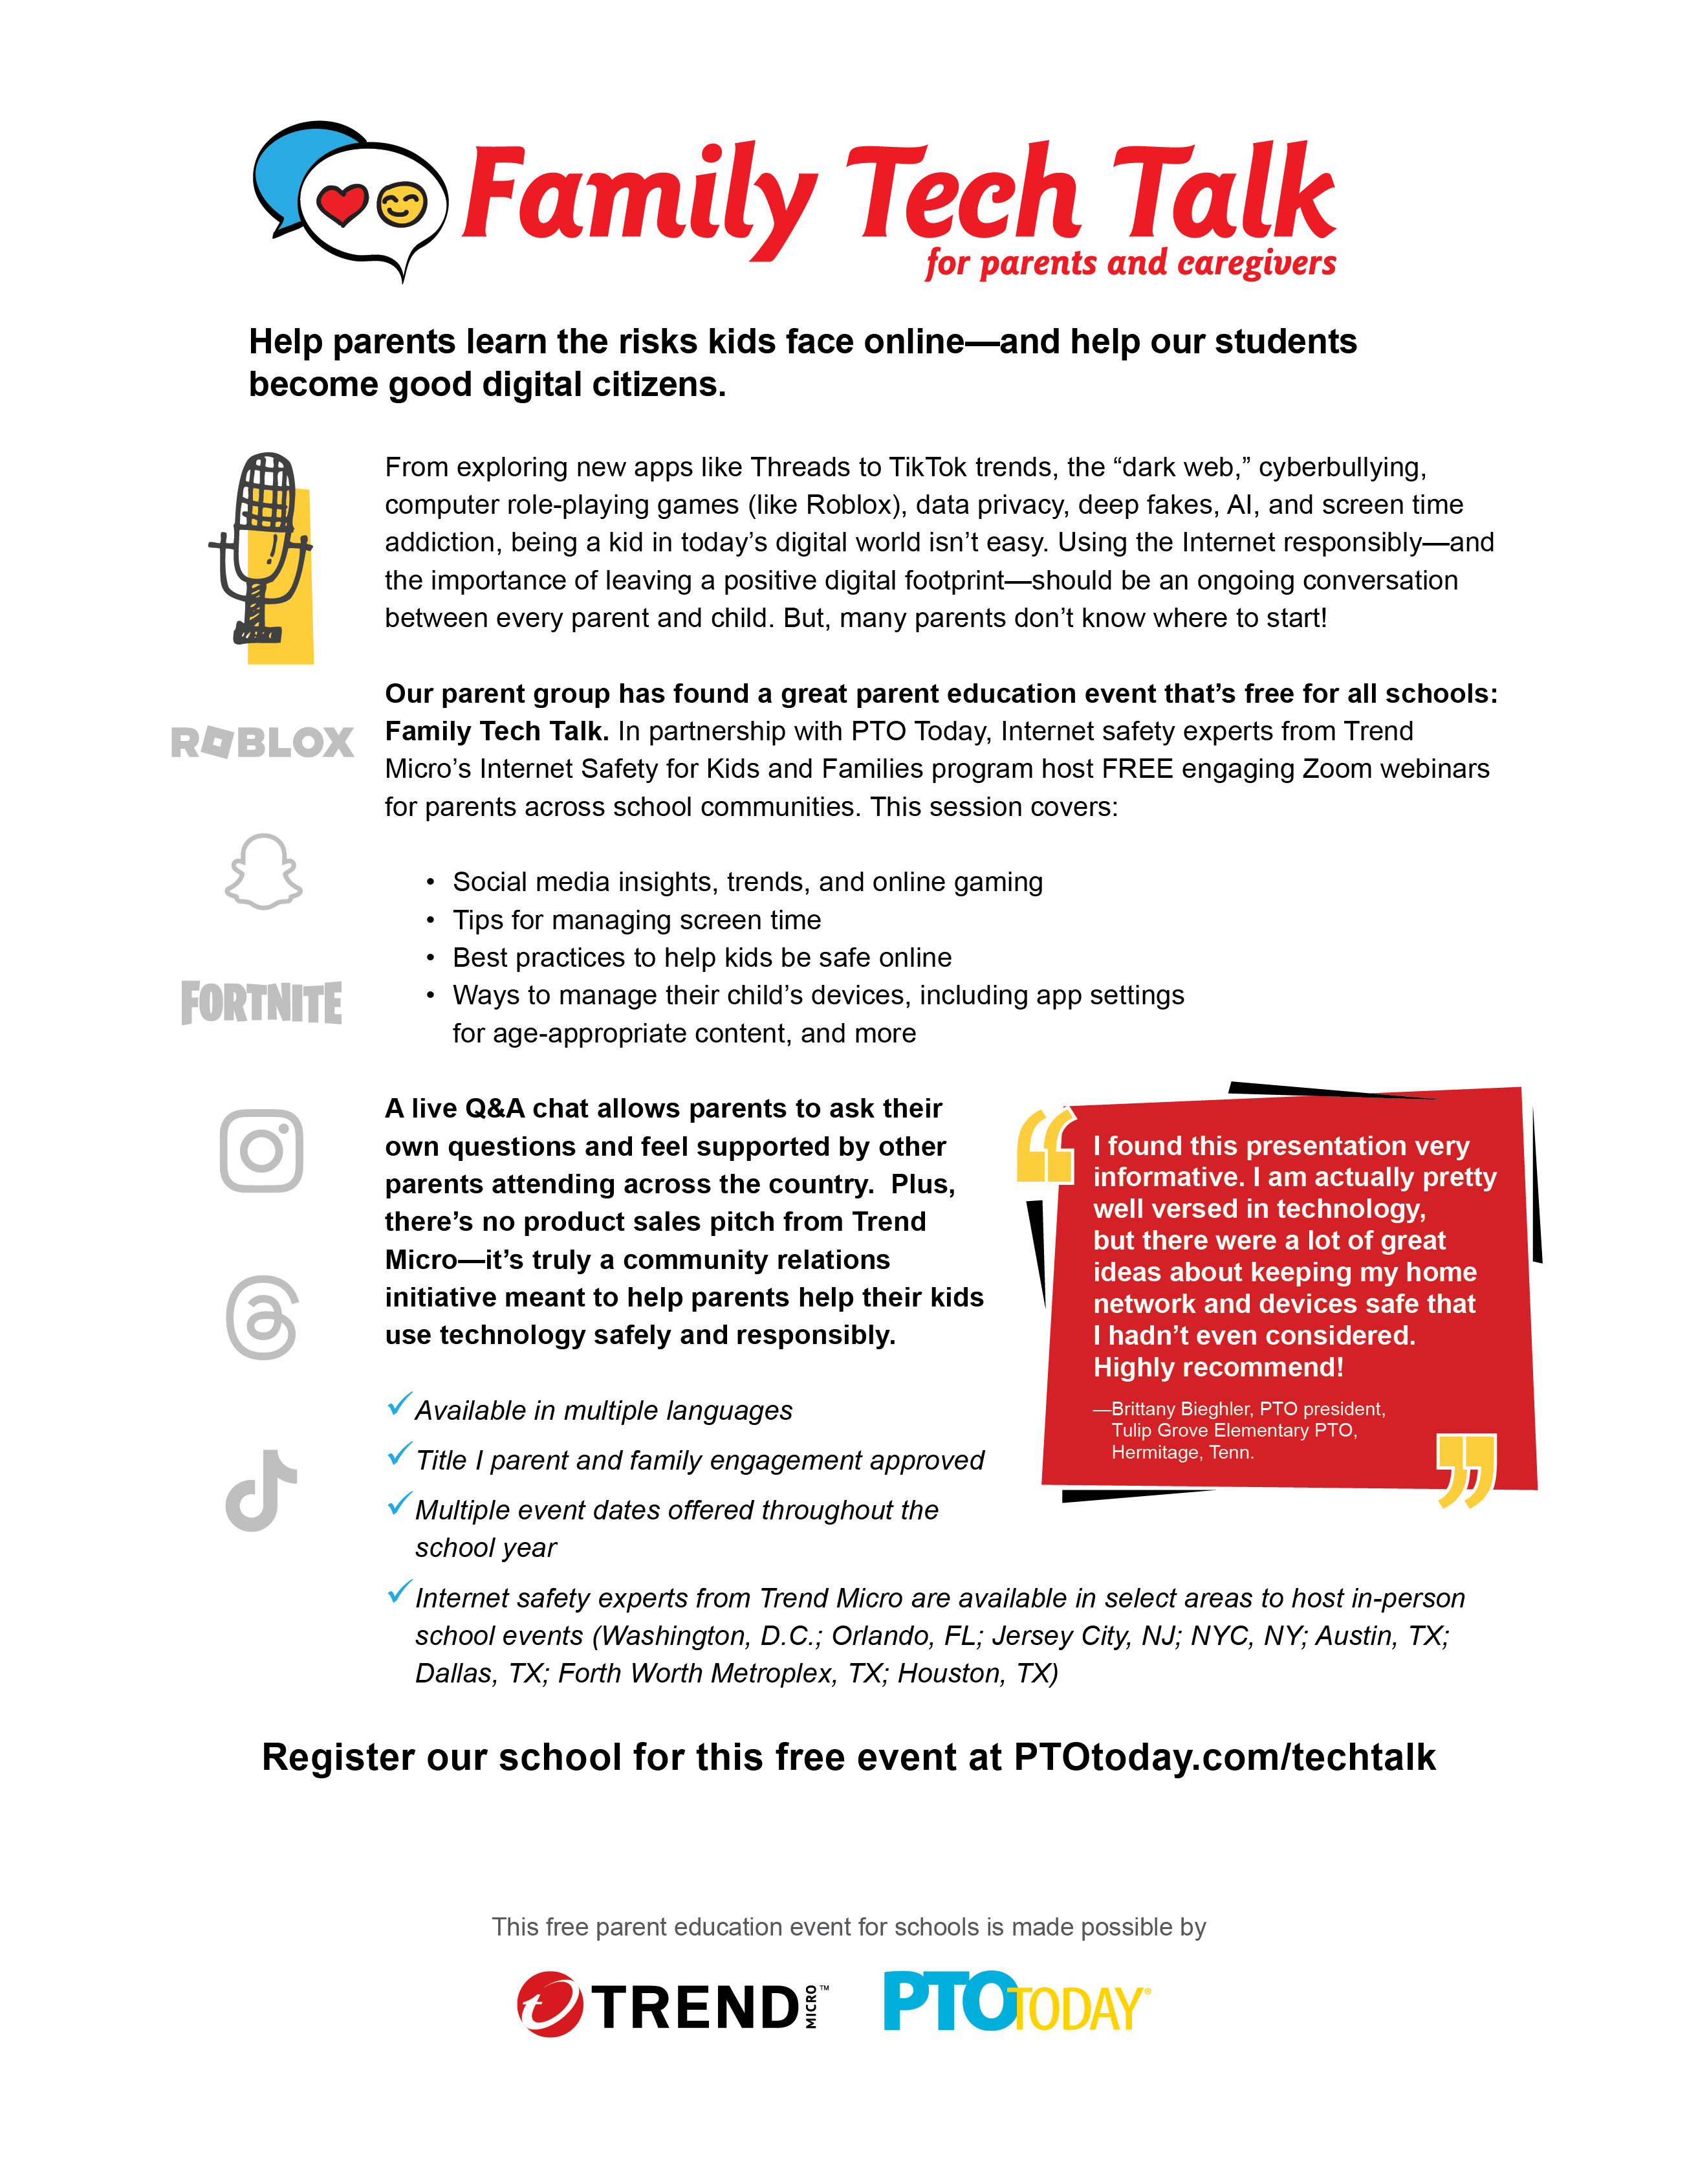­­

**[ Your parent group name here ]**